**SOP FOR**

1. **PURPOSE: Safe maintenance of BFRV maintenance.**
2. **SCOPE:** **Blast Furnace Accessories.**
3. **RESPONSIBILITY: Engineer In charge & Maintenance Fitter on job.**
4. **PROCEDURE: Lower Seal valve Maintenance.**

PPE –s to be used :

* Helmet, Co monitor, dust mask Safety shoes, hand gloves and complete sealed goggle
* Work No 1 : Burden flow regulating valve Motor replacement.
* Work No 2 : Burden flow regulating valve sector gears inspection.
* Work No 3 : Burden flow regulating valve cleaning

Aspect- Impact

Scrap generation Resource Depletion

|  |  |
| --- | --- |
| Oil & Grease spillage | Land contamination & Resource Depletion |
| Fumes | Health |

Hazards identified

### Mechanical hazard - Fall of flange, bolts, wedges, rod etc.

### Fall of person due to grease & oil spillage on platform

### Impact with structure due to lower head room.

### Spillage of oil into the eyes while handling Oil.

Physical Hazard Explosion, Fire, Temperature, Pressure

Chemical Hazard - Gas poisoning.

Electrical Electric shock.

Behavioral Hazards: working without all required PPE’s

Working under influence of alcohol

Horse play

Casual approach

Not following SOP/WI while carrying out the job

Work No 1 : Burden flow regulating valve motor & gear box replacement.

1. Take clearance from production SS for working at furnace top by taking work permit.
2. Furnace shutdown to be taken and Top firing to be carried out.
3. Do carry 2nos CO detector and monitor it continuously.
4. Ensure Burden flow regulating valve should be in closed condition before taking shutdown(possibilities of closing the gate with its self-weight after decouple).
5. Take electrical shutdown of equipment.
6. Remove electrical cable connection.
7. Consult Instrumentation dept. & inform them to carry out necessary isolation as equipment involves Servo drive.
8. Remove coupling guard.
9. De- couple the drive by loosening the coupling bolts.
10. Check coupling bush for any damage
11. Remove the foundation bolts of gear box and replace with spare assembly.

**Note**: Incase only the electrical drive has to be replaced then directly motor- gear box flange bolts can be removed and motor assembly can be replaced.

1. Couple the drive after tightening the foundation bolts.
2. Check for availability of sufficient oil in gear box.
3. Electrical cable connection.
4. Fix the coupling guard and clear electrical shutdown.
5. Inform Instrumentation for their clearance to start the drive for trials.
6. Inform control room in charge to take trial of gear box and motor 3-4 times.
7. Clear the work permit and give clearance.

Work No 2 : Burden flow regulating valve sector gears inspection.

1.Take clearance from production SS for working at furnace top by taking work permit.

2.Do carry 2nos CO detector and monitor it continuously.

3.Take electrical shutdown of equipment.

4.Remove Sector gear housing top cover bolts.

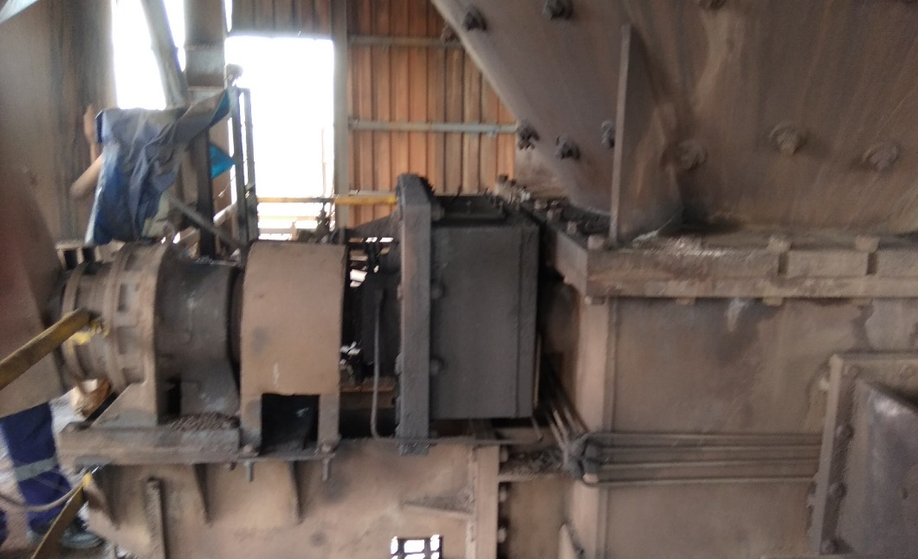

BFRV Sector gear housing

Top cover

Top cover

5.Remove the grease from housing manually.

6. Check the condition of drive gears.

7. Check the condition of connecting arm,mounting pin & bushes for any clearance.

8. After inspection fill the housing with grease.

9. Put back the cover & tighten the bolts.

**10. Clear the shutdown & take trial.**

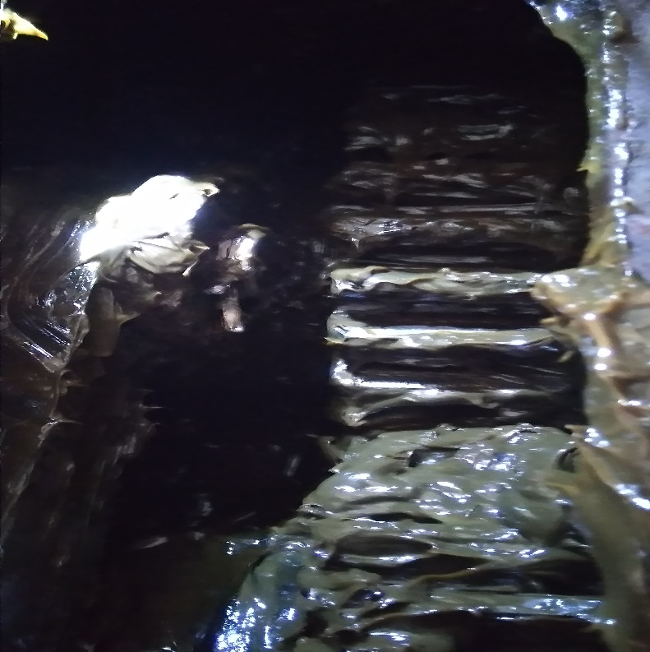

Arm

Gear

Gear

Work No 2 : Burden flow regulating valve Cleaning.

1. Take clearance from production SS for working at furnace top by taking work permit.
2. Furnace shutdown to be taken and Top firing to be carried out.
3. Do carry 2nos CO detector and monitor it continuously.
4. Ensure Burden flow regulating valve should be in open condition before taking shutdown.
5. Take electrical shutdown of equipment.
6. Open the inspection door of BFRV.
7. Use compressed air by using hose for cleaning all corner edges of valve to clean the stuck matrial near valve so valve can operate smoothly.
8. Close the inspection door
9. Clear electrical shutdown and workpermit.

DO:

* Monitor Co levels continuously.

DONT’S

* Start the motor gear box unit unless coupling guard is put in place.

**REFERENCES: Operation & Maintenance manual.**

**Amendement Record**

|  |  |  |  |
| --- | --- | --- | --- |
| **Date** | **Manual Section Ref. & Para** | **Brief details of Revision** | **New Rev.** |
|  |  |  |  |
|  |  |  |  |
|  |  |  |  |

|  |  |  |
| --- | --- | --- |
| **Prepared By:**  Area Engineer | **Reviewed & Issued By:**  Management Representative | **Approved By:**  Mechanical Head |
| **Signature:** | **Signature:** | **Signature:** |
| **Review Date: 14.09.2022** | **Review Date: 14.09.2022** | **Review Date: 14.09.2022** |